Tasks 1: Database Design:
Q1 : Create the database named "HMBank" .
Query :
mysql> CREATE DATABASE HMBank;
Query OK, 1 row affected (0.08 sec)
Q2 : Define the schema for the Customers, Accounts, and Transactions tables based on the provided schema.
Query :
mysql> CREATE TABLE Customers (
-> customer_id INT PRIMARY KEY AUTO_INCREMENT,
-> first_name VARCHAR(100) NOT NULL,
-> last_name VARCHAR(100) NOT NULL,
-> DOB DATE NOT NULL,
-> email VARCHAR(150) UNIQUE NOT NULL,
-> phone_number VARCHAR(15) NOT NULL,
-> address VARCHAR(255)
-> );
Query OK, 0 rows affected (0.05 sec)

mysql> CREATE TABLE Accounts (
-> account_id INT PRIMARY KEY AUTO_INCREMENT,
-> customer_id INT,
-> account_type ENUM('savings', 'current', 'zero_balance') NOT NULL,
-> balance DECIMAL(15, 2) DEFAULT 0.00,
-> FOREIGN KEY (customer_id) REFERENCES Customers(customer_id) ON DELETE CASCADE
-> );
Query OK, 0 rows affected (0.03 sec)

mysql> CREATE TABLE Transactions (
-> transaction_id INT PRIMARY KEY AUTO_INCREMENT,
-> account_id INT,
-> transaction_type ENUM('deposit', 'withdrawal', 'transfer') NOT NULL,
-> amount DECIMAL(15, 2) NOT NULL,
-> transaction_date TIMESTAMP DEFAULT CURRENT_TIMESTAMP,
-> FOREIGN KEY (account_id) REFERENCES Accounts(account_id) ON DELETE CASCADE
-> );
Query OK, 0 rows affected (0.02 sec)
Q3 : Create an ERD (Entity Relationship Diagram) for the database.
Query : 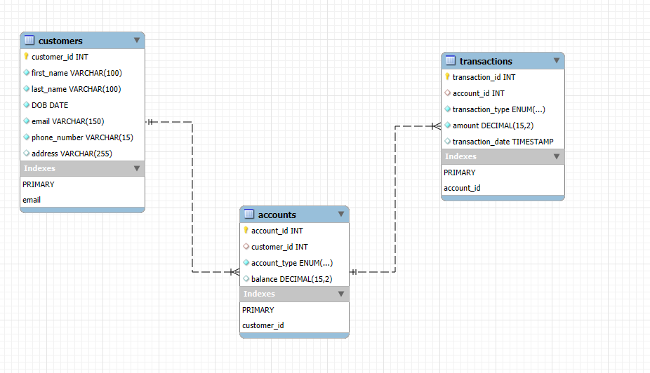

Q4 : Create appropriate Primary Key and Foreign Key constraints for referential integrity.
Query :-
Customers:- The primary key is customer_id.
Accounts:- The primary key is account_id, and there is a foreign key reference to customer_id in the Customers table.
Transactions:- The primary key is transaction_id, and there is a foreign key reference to account_id in the Accounts table.

Q5 : Write SQL scripts to create the mentioned tables with appropriate data types, constraints, and relationships.
• Customers
• Accounts
• Transactions.
Query :
-- CREATE TABLE Customers (
-- customer_id INT PRIMARY KEY AUTO_INCREMENT,
-- first_name VARCHAR(100) NOT NULL,
-- last_name VARCHAR(100) NOT NULL,
-- DOB DATE NOT NULL,
-- email VARCHAR(150) UNIQUE NOT NULL,
-- phone_number VARCHAR(15) NOT NULL,
-- address VARCHAR(255)
-- );

-- CREATE TABLE Accounts (
-- account_id INT PRIMARY KEY AUTO_INCREMENT,
-- customer_id INT,
-- account_type ENUM('savings', 'current', 'zero_balance') NOT NULL,
-- balance DECIMAL(15, 2) DEFAULT 0.00,
-- FOREIGN KEY (customer_id) REFERENCES Customers(customer_id) ON DELETE CASCADE
-- );

-- CREATE TABLE Transactions (
-- transaction_id INT PRIMARY KEY AUTO_INCREMENT,
-- account_id INT,
-- transaction_type ENUM('deposit', 'withdrawal', 'transfer') NOT NULL,
-- amount DECIMAL(15, 2) NOT NULL,
-- transaction_date TIMESTAMP DEFAULT CURRENT_TIMESTAMP,
-- FOREIGN KEY (account_id) REFERENCES Accounts(account_id) ON DELETE CASCADE
-- );
Accounts Table :-
Query:- Select * from accounts;
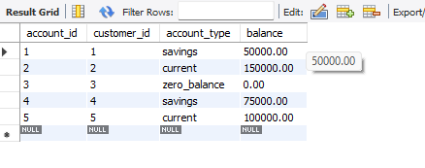
Customers Table:-
Query:- Select * from customers;

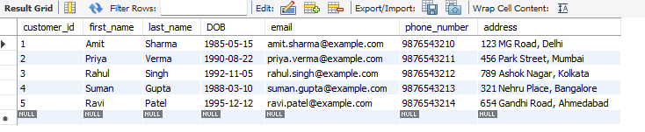
Transactions Table:-
Query:- select * from transactions;
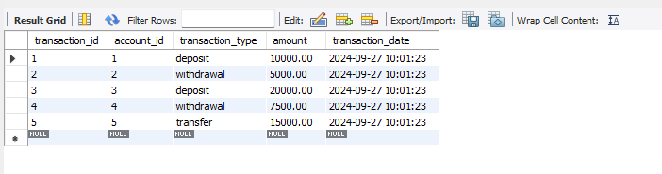
Tasks2:Select,Where,Between,AND,LIKE:
Q1 : Insert at least 10 sample records into each of the following tables.
Query:
•Customers
INSERT INTO Customers (first_name, last_name, DOB, email, phone_number, address) VALUES
('Amit', 'Sharma', '1990-05-12', 'amit.sharma@gmail.com', '9876543210', 'Mumbai'),
('Rahul', 'Verma', '1985-02-23', 'rahul.verma@gmail.com', '9123456789', 'Delhi'),
('Pooja', 'Patel', '1992-11-05', 'pooja.patel@gmail.com', '9876543211', 'Ahmedabad'),
('Suresh', 'Kumar', '1980-07-20', 'suresh.kumar@gmail.com', '9876543212', 'Bangalore'),
('Ravi', 'Naidu', '1995-03-14', 'ravi.naidu@gmail.com', '9876543213', 'Chennai'),
('Meena', 'Joshi', '1988-08-25', 'meena.joshi@gmail.com', '9876543214', 'Pune'),
('Anjali', 'Reddy', '1993-12-30', 'anjali.reddy@gmail.com', '9876543215', 'Hyderabad'),
('Kiran', 'Gupta', '1996-01-22', 'kiran.gupta@gmail.com', '9876543216', 'Kolkata'),
('Vikas', 'Singh', '1991-09-17', 'vikas.singh@gmail.com', '9876543217', 'Chandigarh'),
('Sunita', 'Yadav', '1982-04-11', 'sunita.yadav@gmail.com', '9876543218', 'Jaipur');

select * from customers;
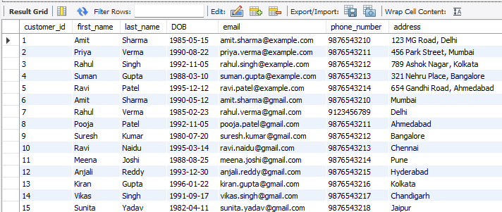
• Accounts
INSERT INTO Accounts (customer_id, account_type, balance) VALUES
(1, 'savings', 5000.00),
(2, 'current', 20000.00),
(3, 'savings', 15000.00),
(4, 'zero_balance', 0.00),
(5, 'savings', 10000.00),
(6, 'current', 30000.00),
(7, 'savings', 7000.00),
(8, 'current', 25000.00),
(9, 'zero_balance', 0.00),
(10, 'savings', 12000.00);

select * from accounts;
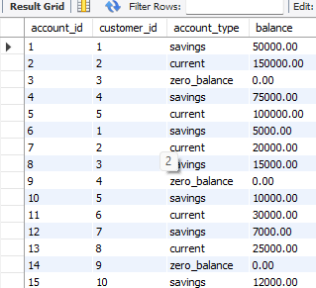
• Transactions
INSERT INTO Transactions (account_id, transaction_type, amount, transaction_date) VALUES
(1, 'deposit', 2000.00, '2024-01-10'),
(2, 'withdrawal', 5000.00, '2024-01-12'),
(3, 'deposit', 4000.00, '2024-02-15'),
(4, 'deposit', 1000.00, '2024-03-05'),
(5, 'withdrawal', 3000.00, '2024-04-18'),
(6, 'transfer', 5000.00, '2024-05-22'),
(7, 'deposit', 6000.00, '2024-06-30'),
(8, 'withdrawal', 7000.00, '2024-07-19'),
(9, 'transfer', 2000.00, '2024-08-01'),
(10, 'deposit', 1500.00, '2024-09-10');

select * from transactions;
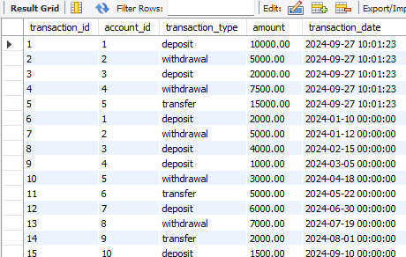

- Write SQL queries for the following tasks:
1. Write a SQL query to retrieve the name, account type and email of all customers.
Query:
SELECT first_name, last_name, account_type, email
FROM Customers
JOIN Accounts ON Customers.customer_id = Accounts.customer_id;
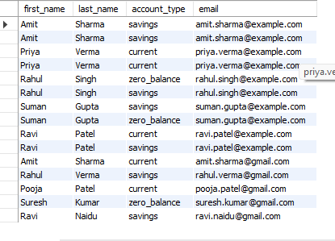
2. Write a SQL query to list all transaction corresponding customer.
Query:-
SELECT first_name, last_name, transaction_type, amount, transaction_date
FROM Customers
JOIN Accounts ON Customers.customer_id = Accounts.customer_id
JOIN Transactions ON Accounts.account_id = Transactions.account_id;

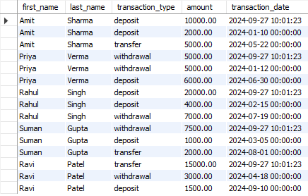
3. Write a SQL query to increase the balance of a specific account by a certain amount.
Query:-
UPDATE Accounts
SET balance = balance + 1000
WHERE account_id = 1;
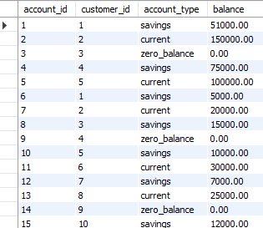
4. Write a SQL query to Combine first and last names of customers as a full_name.
Query:-

SELECT CONCAT(first_name, ' ', last_name) AS full_name
FROM Customers;
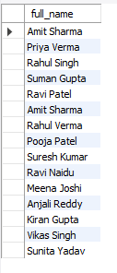
5. Write a SQL query to remove accounts with a balance of zero where the account type is savings.
Query:-
DELETE FROM Accounts
WHERE balance = 0 AND account_type = 'savings';
After Delete Query
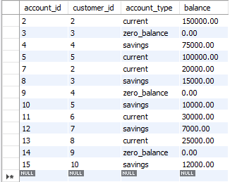
6. Write a SQL query to Find customers living in a specific city.
Query:-
SELECT first_name, last_name
FROM Customers
WHERE address LIKE '%Mumbai%';

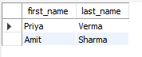
7.Write a SQL query to Get the account balance for a specific account..
Query:-
SELECT balance
FROM Accounts
WHERE account_id = 5;
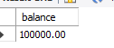
8. Write a SQL query to List all current accounts with a balance greater than $1,000.
Query:-
SELECT account_id, balance
FROM Accounts
WHERE account_type = 'current' AND balance > 1000;
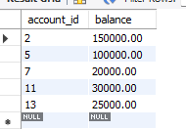

9. Write a SQL query to Retrieve all transactions for a specific account.
Query:-
SELECT transaction_type, amount, transaction_date
FROM Transactions
WHERE account_id = 5;
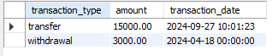
10. Write a SQL query to Calculate the interest accrued on savings accounts based on a given interest rate.
Query:-
SELECT account_id, balance, (balance * 0.04) AS interest_accrued
FROM Accounts
WHERE account_type = 'savings';
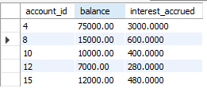
11. Write a SQL query to Identify accounts where the balance is less than a specified overdraft limit.
Query:-
SELECT account_id, balance
FROM Accounts
WHERE balance < 5000;
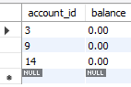

12. Write a SQL query to Find customers not living in a specific city.
Query:-
SELECT first_name, last_name
FROM Customers
WHERE address NOT LIKE '%Delhi%';

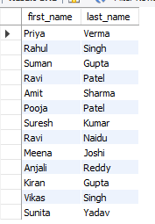
Tasks 3: Aggregate functions, Having, Order By, GroupBy and Joins:
1. Write a SQL query to Find the average account balance for all customers.
Query:
SELECT AVG(balance) AS average_balance
FROM Accounts;
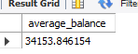

2. Write a SQL query to Retrieve the top 10 highest account balances.
Query:
SELECT account_id, balance
FROM Accounts
ORDER BY balance DESC
LIMIT 10;
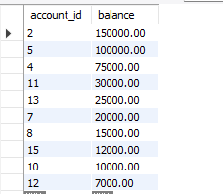
3.Write a SQL query to Calculate Total Deposits for All Customers on a specific date.
Query:
SELECT SUM(amount) AS total_deposits
FROM Transactions
WHERE transaction_type = 'deposit' AND transaction_date = '2024-09-10'
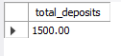
;
4.Write a SQL query to Find the Oldest and Newest Customers.
Query:
SELECT
MIN(DOB) AS oldest_customer,
MAX(DOB) AS newest_customer
FROM Customers;
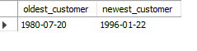

5.Write a SQL query to Retrieve transaction details along with the account type.
Query:
SELECT
t.transaction_id,
t.transaction_type,
t.amount,
t.transaction_date,
a.account_type
FROM Transactions t
JOIN Accounts a ON t.account_id = a.account_id;
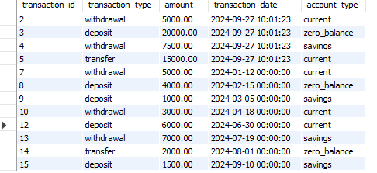

6.Write a SQL query to Get a list of customers along with their account details.
Query:
SELECT
c.customer_id,
c.first_name,
c.last_name,
a.account_id,
a.account_type,
a.balance
FROM Customers c
JOIN Accounts a ON c.customer_id = a.customer_id;
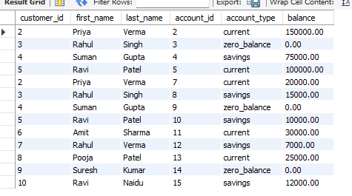

7.Write a SQL query to Retrieve transaction details along with customer information for a specific account.
Query:
SELECT
t.transaction_id,
t.transaction_type,
t.amount,
t.transaction_date,
c.first_name,
c.last_name
FROM Transactions t
JOIN Accounts a ON t.account_id = a.account_id
JOIN Customers c ON a.customer_id = c.customer_id
WHERE a.account_id = '4';
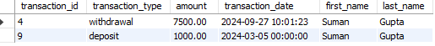

8.Write a SQL query to Identify customers who have more than one account.
Query:
SELECT
c.customer_id,
c.first_name,
c.last_name,
COUNT(a.account_id) AS account_count
FROM Customers c
JOIN Accounts a ON c.customer_id = a.customer_id
GROUP BY c.customer_id
HAVING COUNT(a.account_id) > 1;
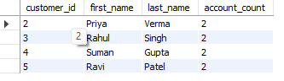
9.Write a SQL query to Calculate the difference in transaction amounts between deposits and withdrawals.
Query:
SELECT
account_id,
SUM(CASE WHEN transaction_type = 'deposit' THEN amount ELSE 0 END) AS total_deposits,
SUM(CASE WHEN transaction_type = 'withdrawal' THEN amount ELSE 0 END) AS total_withdrawals,
SUM(CASE WHEN transaction_type = 'deposit' THEN amount ELSE 0 END) -
SUM(CASE WHEN transaction_type = 'withdrawal' THEN amount ELSE 0 END) AS difference
FROM Transactions
GROUP BY account_id;
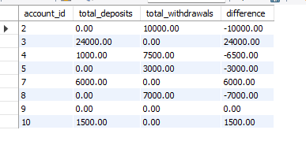

10.Write a SQL query to Calculate the average daily balance for each account over a specified period.
Query:
SELECT
a.account_id,
(SUM(CASE WHEN t.transaction_type = 'deposit' THEN t.amount ELSE 0 END) -
SUM(CASE WHEN t.transaction_type = 'withdrawal' THEN t.amount ELSE 0 END)) /
COUNT(DISTINCT t.transaction_date) AS average_daily_balance
FROM Accounts a
LEFT JOIN Transactions t ON a.account_id = t.account_id
WHERE t.transaction_date BETWEEN '2024-02-15' AND '2024-09-10'
GROUP BY a.account_id;
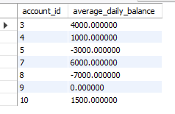
11.Calculate the total balance for each account type.
Query:

SELECT
account_type,
SUM(balance) AS total_balance
FROM Accounts
GROUP BY account_type;
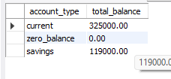

12. Identify accounts with the highest number of transactions order by descending order.
Query:
SELECT
a.account_id,
COUNT(t.transaction_id) AS transaction_count
FROM Accounts a
JOIN Transactions t ON a.account_id = t.account_id
GROUP BY a.account_id
ORDER BY transaction_count DESC;

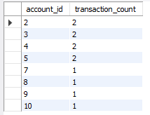

13.List customers with high aggregate account balances, along with their account types.
Query:
SELECT
c.customer_id,
c.first_name,
c.last_name,
SUM(a.balance) AS total_balance,
a.account_type
FROM Customers c
JOIN Accounts a ON c.customer_id = a.customer_id
GROUP BY c.customer_id, a.account_type
HAVING total_balance >’7000’;
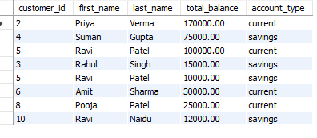

14. Identify and list duplicate transactions based on transaction amount, date, and account.
Query:
SELECT
amount,
transaction_date,
account_id,
COUNT(*) AS duplicate_count
FROM Transactions
GROUP BY amount, transaction_date, account_id
HAVING COUNT(*) > 1;
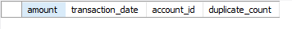
No value is Duplicate.

Tasks 4: Subquery and its type:
1. Retrieve the customer(s) with the highest account balance.
Query:
SELECT c.customer_id, c.first_name, c.last_name, MAX(a.balance) AS highest_balance
FROM Customers c
JOIN Accounts a ON c.customer_id = a.customer_id
GROUP BY c.customer_id, c.first_name, c.last_name
HAVING MAX(a.balance) = (SELECT MAX(balance) FROM Accounts);
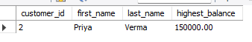

2. Calculate the average account balance for customers who have more than one account.
Query:
SELECT AVG(a.balance) AS average_balance
FROM Accounts a
WHERE a.customer_id IN (
SELECT customer_id
FROM Accounts
GROUP BY customer_id
HAVING COUNT(account_id) > 1
);
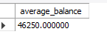

3. Retrieve accounts with transactions whose amounts exceed the average transaction amount. .
Query:
SELECT a.account_id, a.account_type, a.balance
FROM Accounts a
WHERE a.account_id IN (
SELECT t.account_id
FROM Transactions t
WHERE t.amount > (SELECT AVG(amount) FROM Transactions)
);
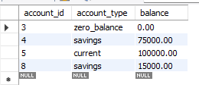
4. Identify customers who have no recorded transactions.
Query:
SELECT c.customer_id, c.first_name, c.last_name
FROM Customers c
WHERE c.customer_id NOT IN (
SELECT DISTINCT a.customer_id
FROM Accounts a
JOIN Transactions t ON a.account_id = t.account_id
);
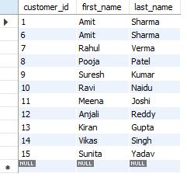

5. Calculate the total balance of accounts with no recorded transactions. .
Query:
SELECT SUM(a.balance) AS total_balance
FROM Accounts a
WHERE a.account_id NOT IN (
SELECT DISTINCT t.account_id
FROM Transactions t
);
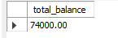
6. Retrieve transactions for accounts with the lowest balance.
Query:
SELECT t.transaction_id, t.amount, t.transaction_date, a.account_id
FROM Transactions t
JOIN Accounts a ON t.account_id = a.account_id
WHERE a.balance = (SELECT MIN(balance) FROM Accounts);
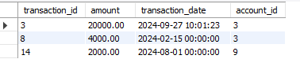
7. Identify customers who have accounts of multiple types.
Query:
SELECT c.customer_id, c.first_name, c.last_name
FROM Customers c
JOIN Accounts a ON c.customer_id = a.customer_id
GROUP BY c.customer_id
HAVING COUNT(DISTINCT a.account_type) > 1;
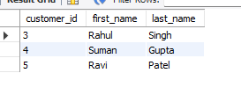

8. Calculate the percentage of each account type out of the total number of accounts.
Query:
SELECT a.account_type,
COUNT(*) AS count,
(COUNT(*) / (SELECT COUNT(*) FROM Accounts) * 100) AS percentage
FROM Accounts a
GROUP BY a.account_type;

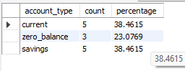

9. Retrieve all transactions for a customer with a given customer_id.
Query:
SELECT t.transaction_id, t.amount, t.transaction_date
FROM Transactions t
JOIN Accounts a ON t.account_id = a.account_id
WHERE a.customer_id = 2;
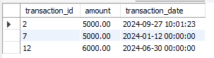

10. Calculate the total balance for each account type, including a subquery within the SELECT clause.
Query:
SELECT a.account_type,
SUM(a.balance) AS total_balance,
(SELECT COUNT(*) FROM Accounts) AS total_accounts
FROM Accounts a
GROUP BY a.account_type;
